**LA 4**

**PRN: 2018BTECS00034**

**Name: Aditya Umesh Gadadhani**

**TY BTech(CSE)-II 4CS372 : Advanced Database System Lab. LA4 (ESE) JUNE 2021 Paper Code : ADS6L44**

**Topic**: Implement CRUD (Create, Read, Update, Delete) in Python for employee table

**Database used**: MySQL

MySQL Database Service is a fully managed database service to deploy cloud-native applications. Heat Wave, an integrated, high-performance query accelerator that boosts MySQL performance by 400x

The SQL part of “MySQL” stands for “Structured Query Language”. SQL is the most common standardized language used to access databases. Depending on your programming environment, you might enter SQL directly (for example, to generate reports), embed SQL statements into code written in another language, or use a language-specific API that hides the SQL syntax.

Assumption and architecture of application:

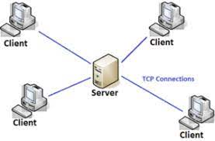

The server basically has a MySQL DBMS and all the clients will be connected to the sever accordingly.

Steps for creating the database;

1. Creating database
2. Creating required tables

Employees (EmpNo number(4), Name varchar2(40), address varchar2(40),Grade number(2), Salary number(10,2),Date_of_joining date)

Steps for Creating the Application

1. Creating the UI in python:
2. Connect the application to the MySQL database:
3. Creating backEnd of the Application to store data.
4. Verifying the DB if the CRUD operations successfully worked or not.

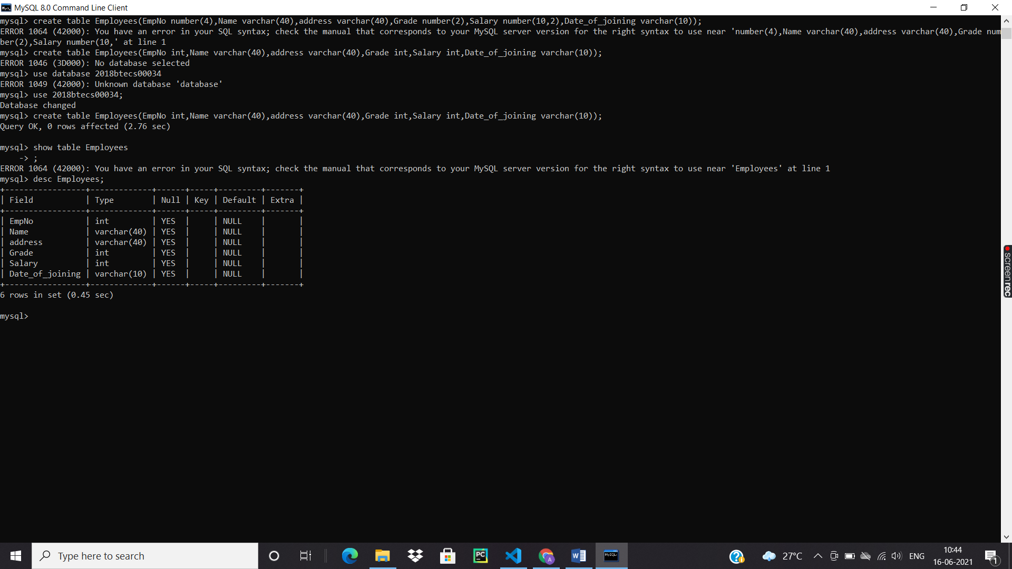



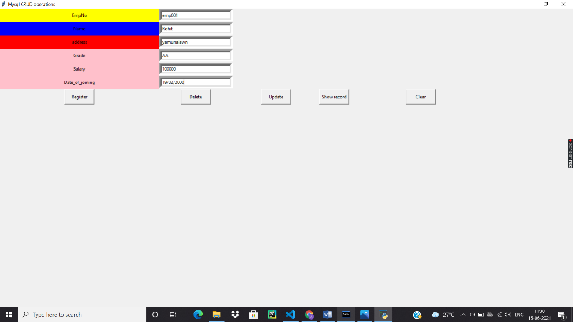

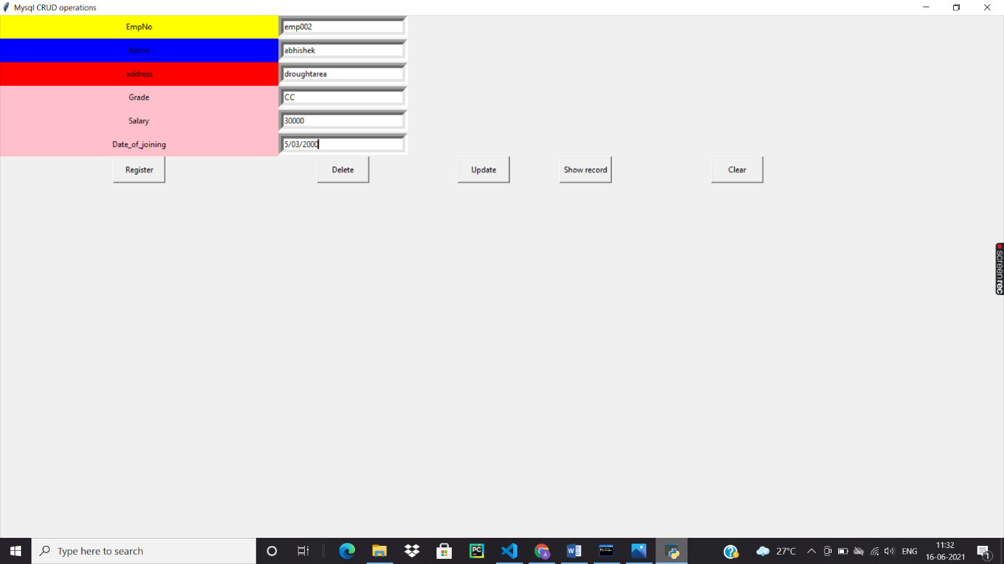

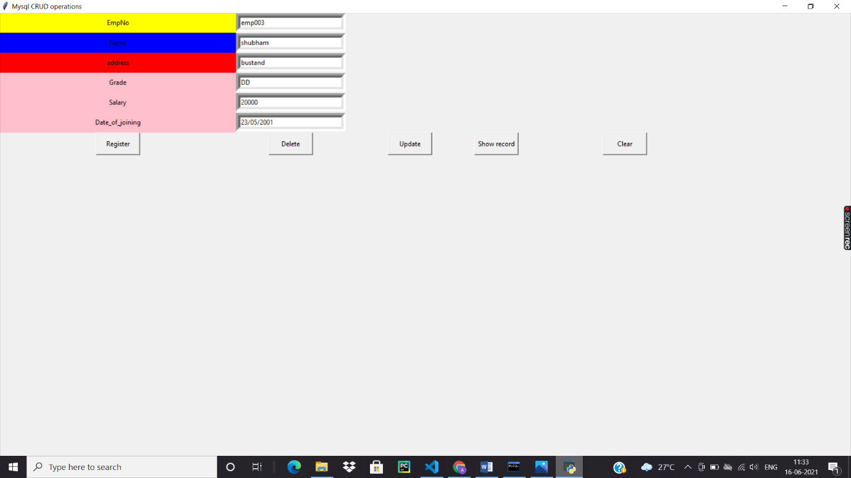

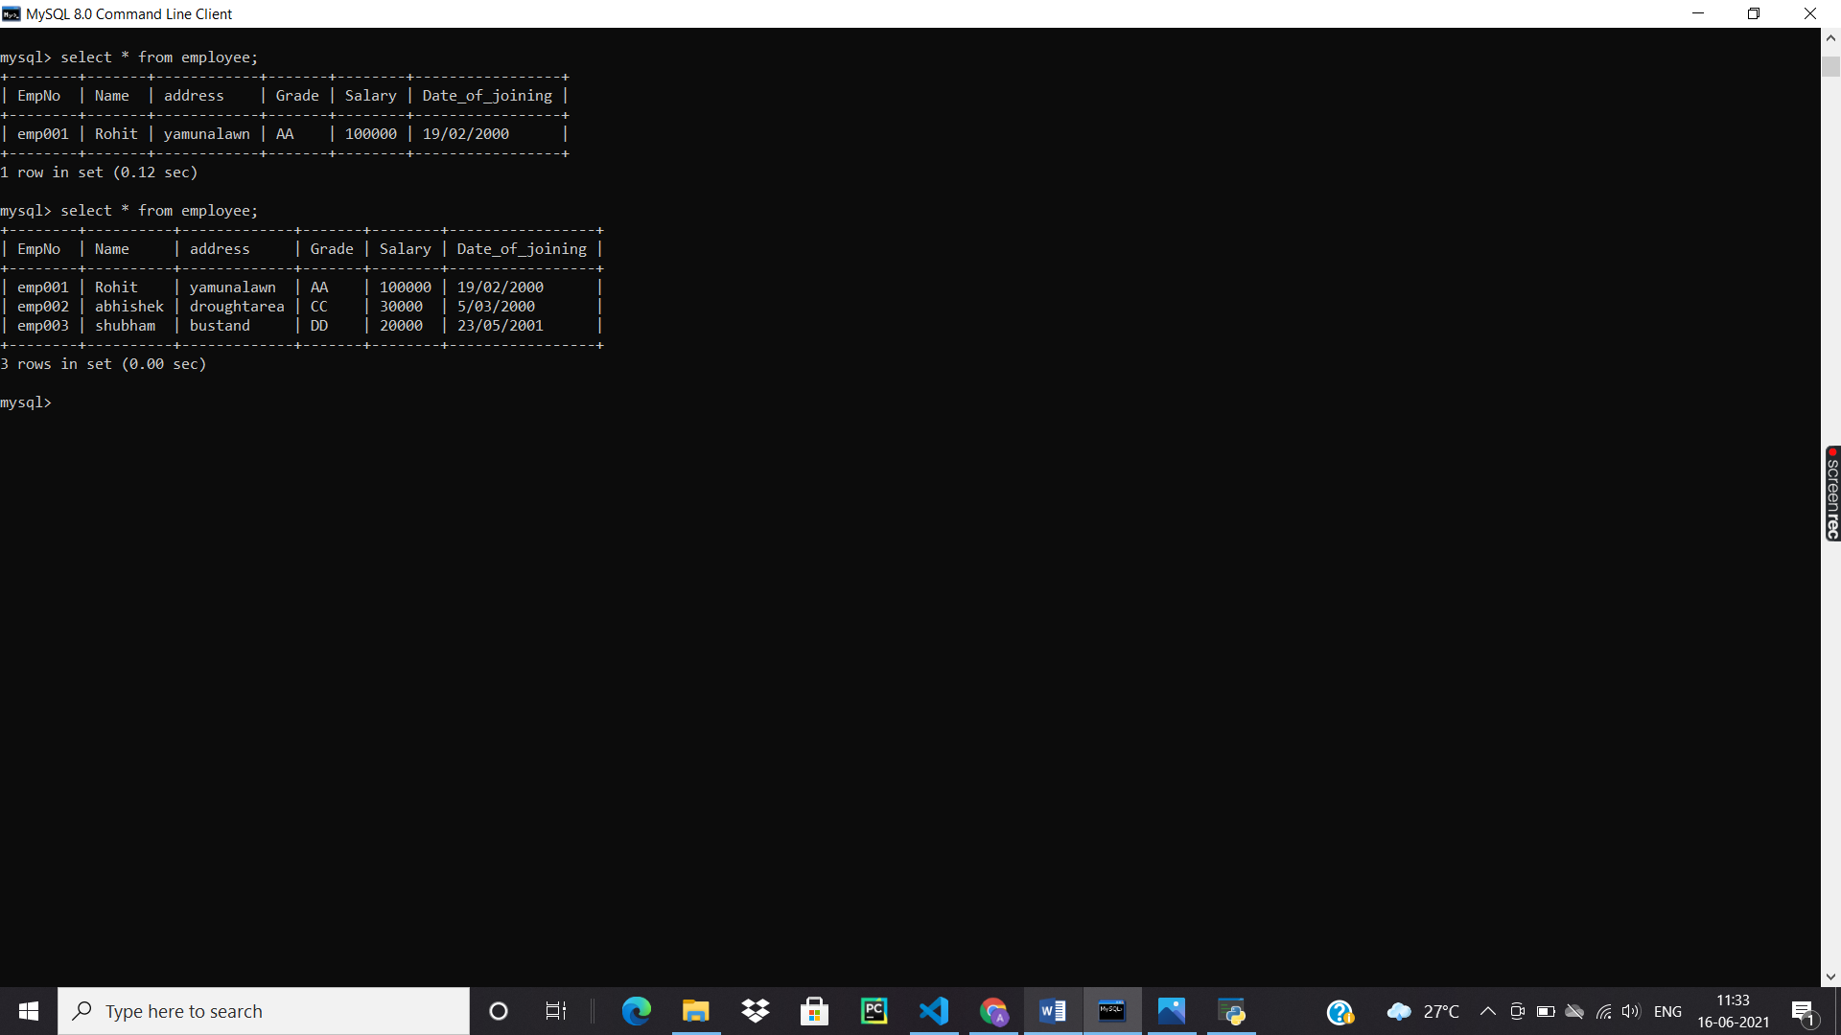

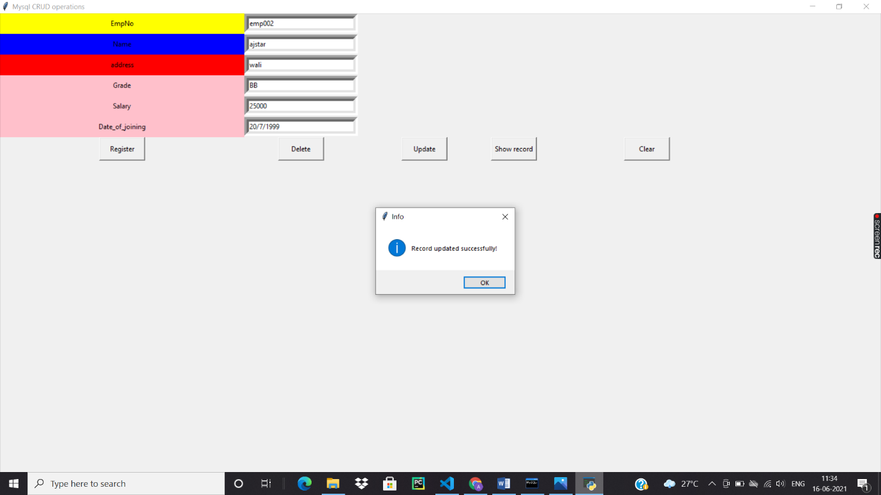

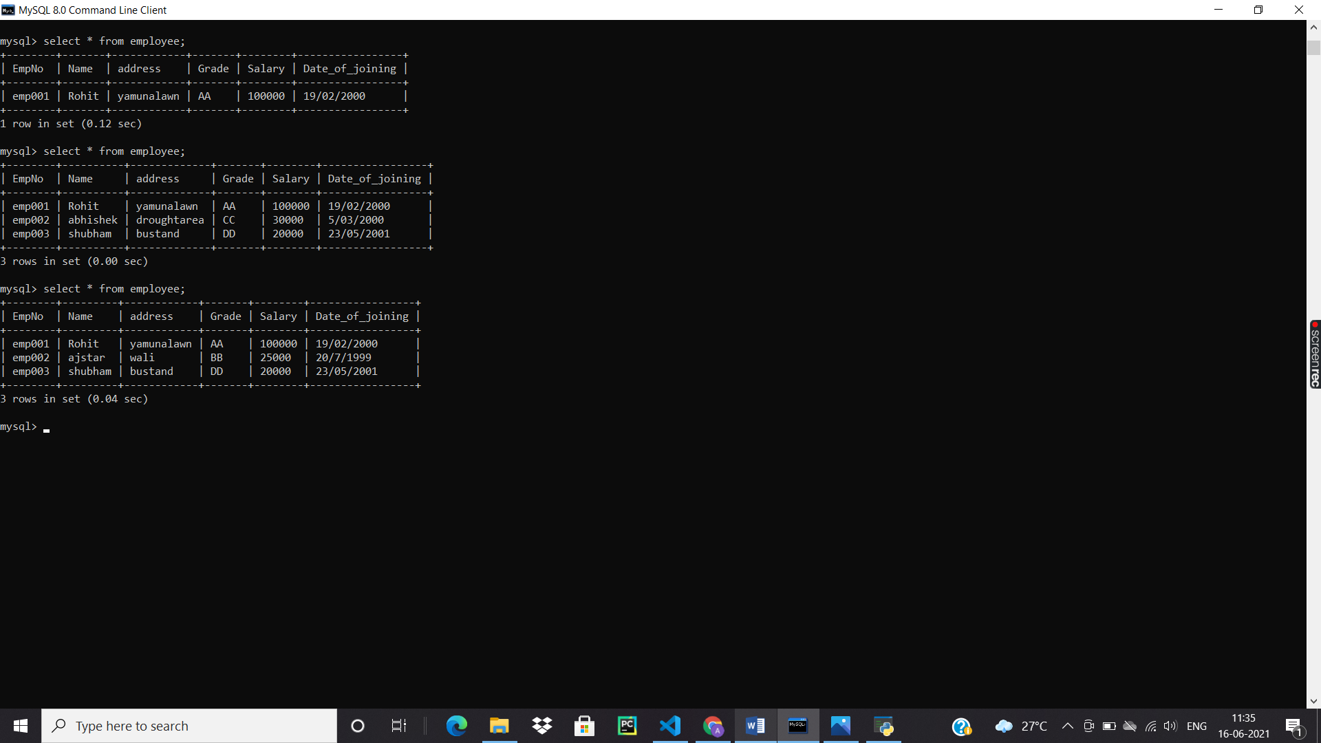

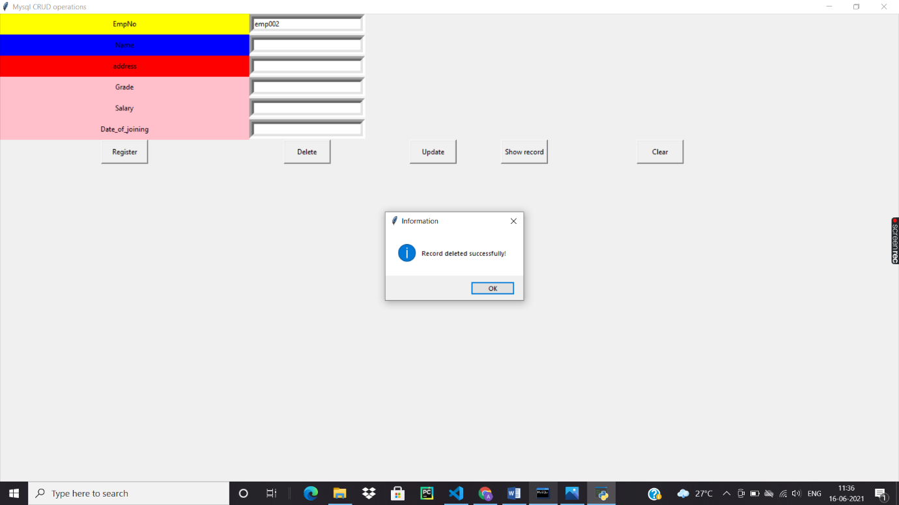

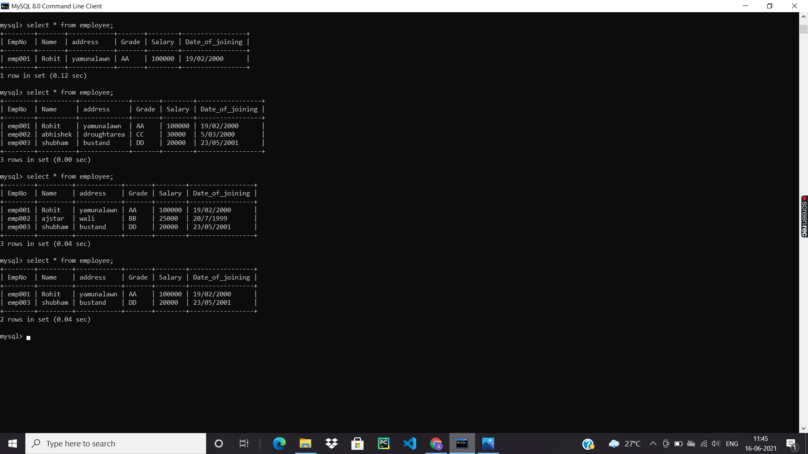

The data entered in the CRUD application is stored in the mySQL data base with unique ID and slot.

**Result and Conclusion** : CRUD application is successfully created and changes are successfully reflected in the databases